Welcome To
Trinity Lutheran Church
Lutheran Church—Missouri Synod
A Stephen Ministry Congregation

1354 South Otsego Avenue
Gaylord, Michigan 49735
Church Phone: (989) 732-4816

Church Email: secretary@trinitygaylord.com
www.trinitygaylord.com

Office Hours: Monday through Friday 9am – 1pm

OUR PURPOSE
…is to LOVE GOD, LOVE OTHERS, AND SERVE THE WORLD by worshiping the Lord Jesus, bringing our members into Christ-like maturity, and equipping them through Word and Sacrament for their mission and ministry. We go heart to heart into the world with Jesus, sharing His love, caring for one another, praying, and bringing the lost into a relationship with Christ, by the working of the Holy Spirit.

August 14, 2022
Tenth Sunday after Pentecost
Preacher: Rev. Ken Bernthal

ABOUT OUR WORSHIP
We welcome all who gather here today! We are blessed to celebrate together the mercy, grace, and love we have from God through the death and resurrection of our Lord Jesus Christ.

Children: Families with children are very welcome here. Having children in church is important so they can begin to learn about their faith in Jesus, and it’s good for the whole congregation to see. Please feel comfortable keeping “squirmy” kids in the service. This is where they belong, too!

Pew Cards: Guests and Members, please fill out the Guest/Member card located on the back of the pew in front of you and pass it to the end of the aisle. If you forget you can put it in the offering plate on your way out.

If standing is difficult: Please feel free to remain seated during any portion of the service. Please let an Elder or Usher know if you need communion in your pew seat.

About our celebration of Holy Communion: We celebrate the Lord’s Supper in the confession and glad confidence that, as he says, our Lord gives into our mouths not only bread and wine but his very body and blood to eat and to drink for the forgiveness of sins and to strengthen our union with him and with one another. Our Lord invites to his table those who trust his words, repent of all sin, and set aside any refusal to forgive and love as he forgives and loves us, that they may show forth his death until he comes.

Because those who eat and drink our Lord’s body and blood contrary to that which is stated above do so to their great harm, and also because Holy Communion is a confession of the faith which is confessed at this altar. Anyone who is not yet instructed, in doubt, or who hold a confession differing from that of the Lutheran Church—Missouri Synod, and yet desire to receive the sacrament, are asked first to speak with Pastor. Those not communing are still invited to come forward for a blessing from Pastor, and you may indicate this by crossing your arms over your chest.
TTTTTT

GREETING

P Peace be with you.
C And also with you.

T ORDER OF SERVICE T
(The liturgy is from Divine Service Setting four LSB pg. 203ff)

OPENING HYMN
Come, Thou Almighty King LSB 905 (please stand on sts. 4)
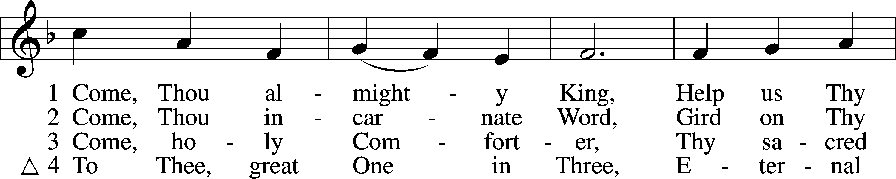
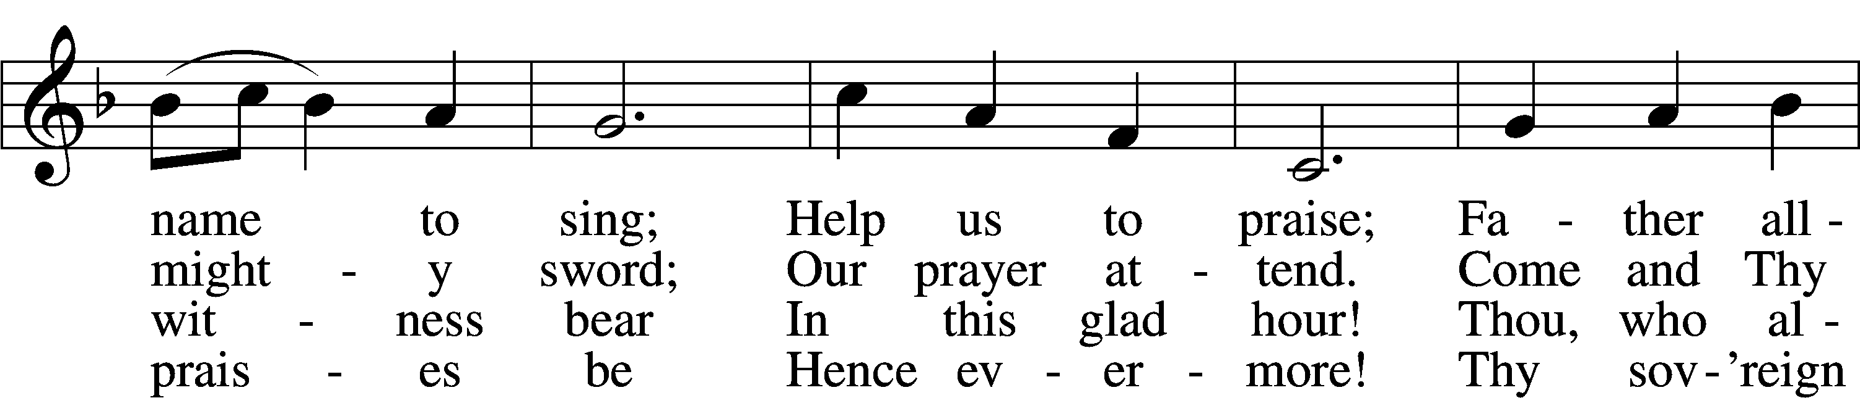
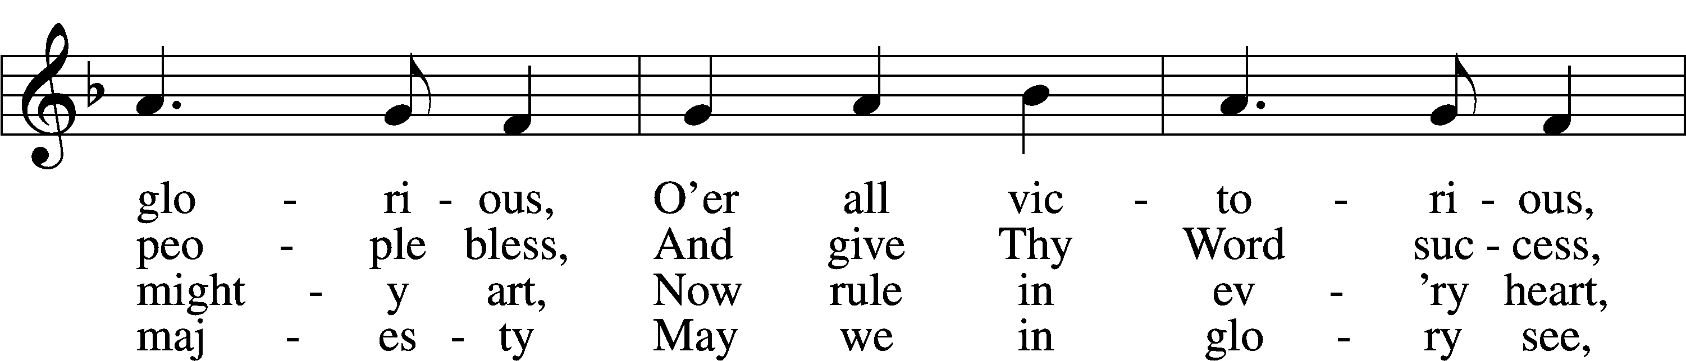
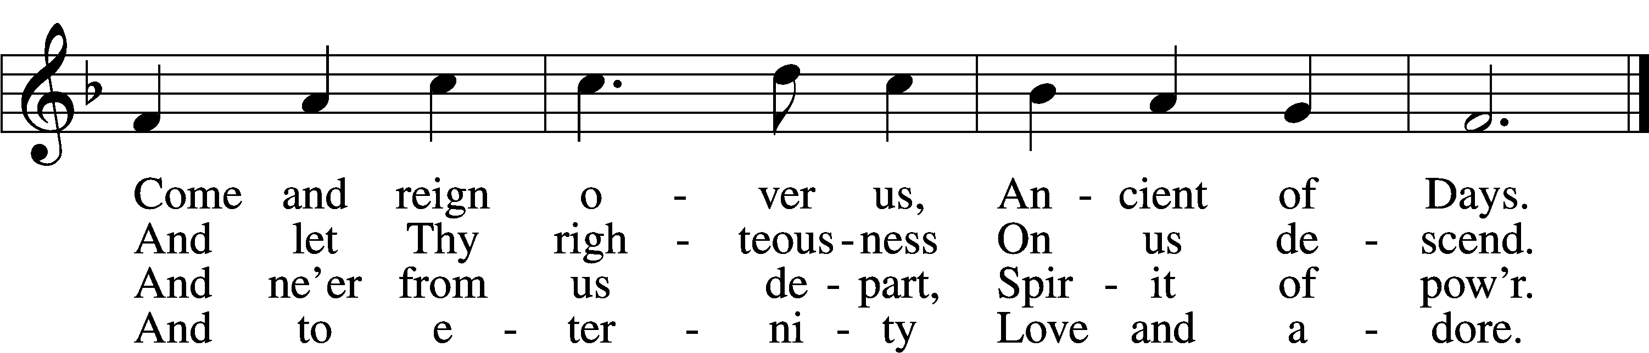
Text: English, before 1760, alt.
Tune: Felice de Giardini, 1716–96
Text and tune: Public domain

CONFESSION and ABSOLUTION
The sign of the cross may be made by all in remembrance of their Baptism.

P In the name of the Father and of the T Son and of the Holy Spirit.
C Amen.
P Our help is in the name of the Lord,
C who made heaven and earth.
P If You, O Lord, kept a record of sins, O Lord, who could stand?
C But with You there is forgiveness; therefore, You are feared.
P Since we are gathered to hear God’s Word, call upon Him in prayer and praise, and receive the body and blood of our Lord Jesus Christ in the fellowship of this altar, let us first consider our unworthiness and confess before God and one another that we have sinned in thought, word, and deed, and that we cannot free ourselves from our sinful condition. Together as His people let us take refuge in the infinite mercy of God, our heavenly Father, seeking His grace for the sake of Christ, and saying: God, be merciful to me, a sinner.
C Almighty God, have mercy upon us, forgive us our sins, and lead us to everlasting life. Amen.
P Almighty God, merciful Father, in Holy Baptism You declared us to be Your children and gathered us into Your one, holy Church, in which You daily and richly forgive us our sins and grant us new life through Your Spirit. Be in our midst, enliven our faith, and graciously receive our prayer and praise; through Your Son, Jesus Christ, our Lord.
C Amen.

SERVICE OF THE WORD
INTROIT Psalm 55:1, 12–14, 16; antiphon: v. 22
P Cast your burden on the Lord, and he will sustain you;
he will never permit the righteous to be moved.
C Give ear to my prayer, O God,
and hide not yourself from my plea for mercy!
P For it is not an enemy who taunts me—then I could bear it;
it is not an adversary who deals insolently with me—then I could hide from him.
C But it is you, a man, my equal,
my companion, my familiar friend.
P We used to take sweet counsel together;
within God’s house we walked in the throng.
C But I call to God,
and the Lord will save me.
A Glory be to the Father and to the Son
and to the Holy Spirit;
as it was in the beginning,
is now, and will be forever. Amen.
P Cast your burden on the Lord, and he will sustain you;
he will never permit the righteous to be moved.
KYRIE LSB 204
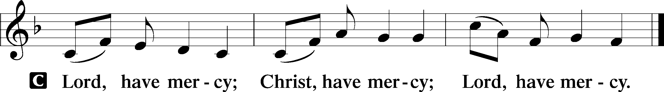

HYMN OF PRAISE
GLORIA IN EXCELSIS LSB 204
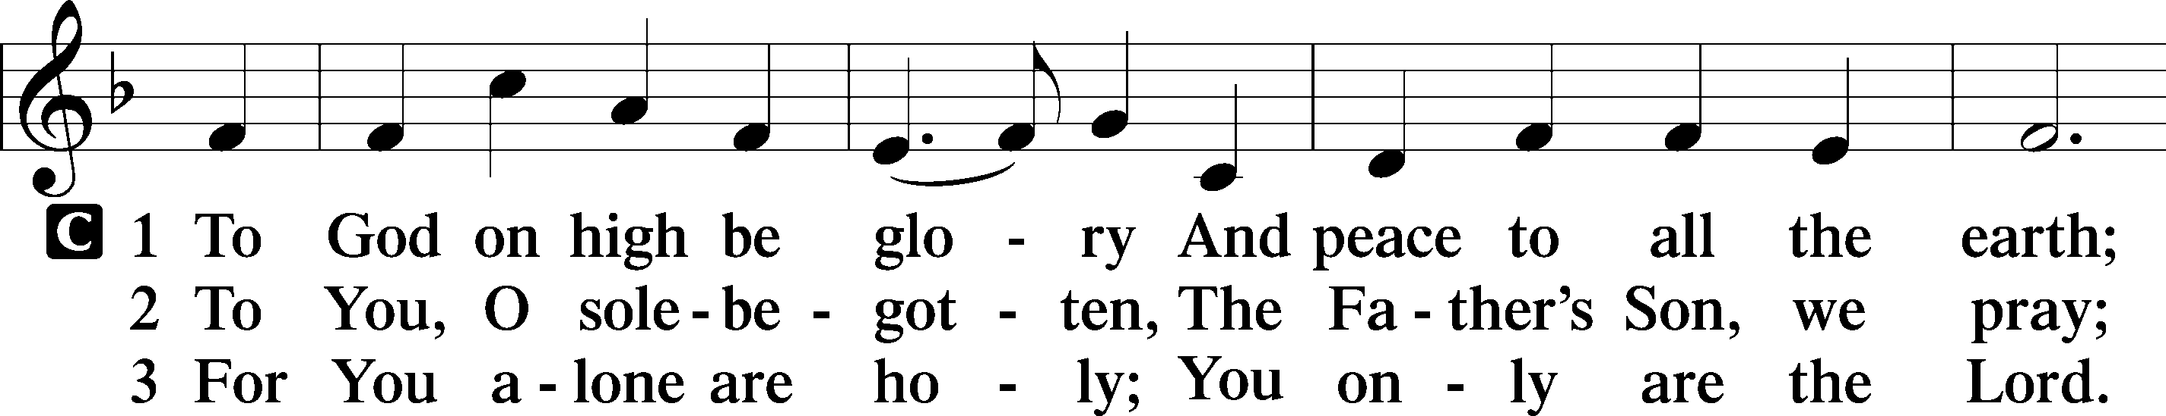
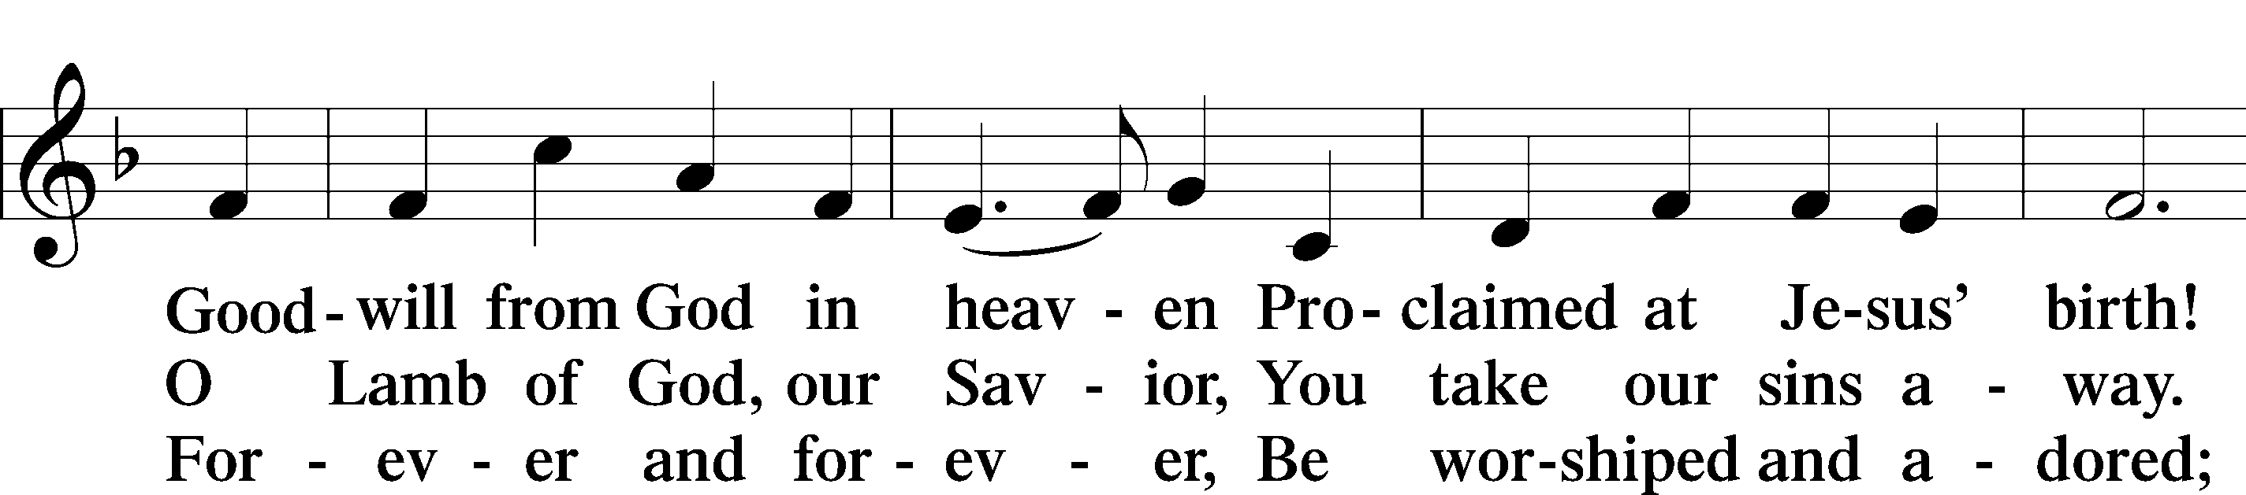

Continued on next page
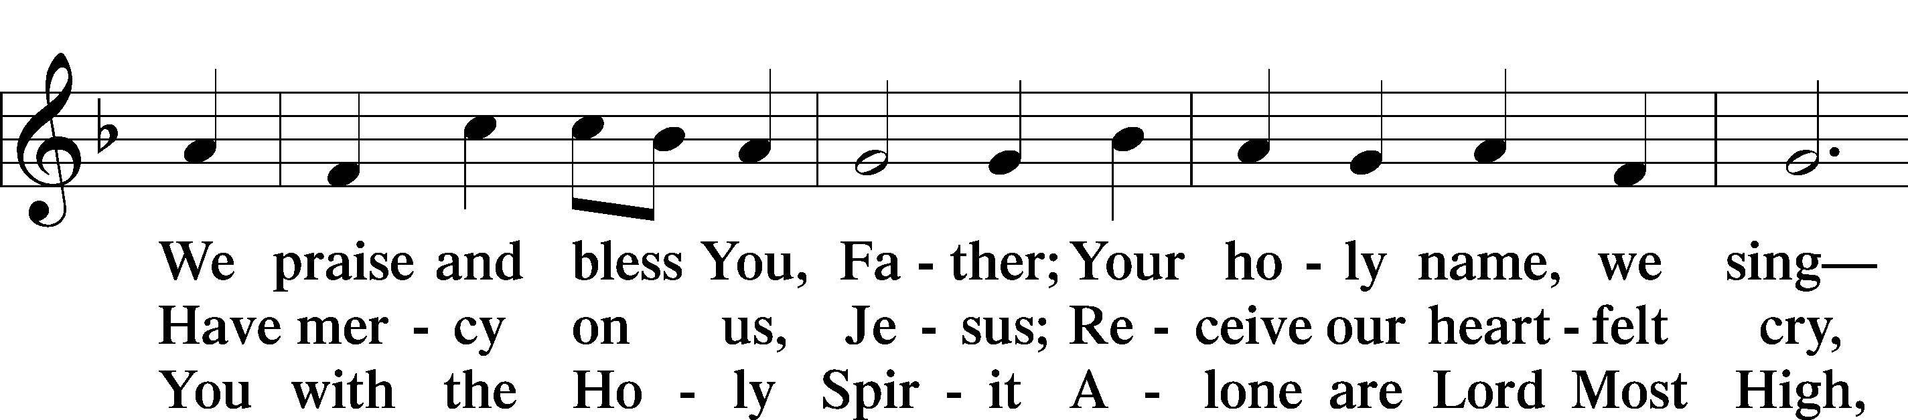
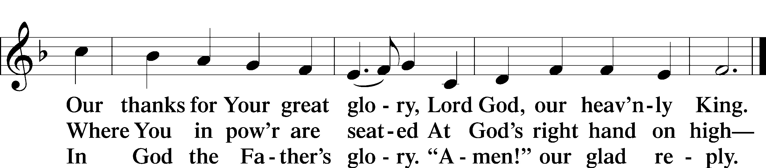
Text: Stephen P. Starke

SALUTATION AND COLLECT OF THE DAY
P The Lord be with you.
C And also with you.
P Let us pray.
Merciful Lord, cleanse and defend Your Church by the sacrifice of Christ. United with Him in Holy Baptism, give us grace to receive with thanksgiving the fruits of His redeeming work and daily follow in His way; through the same Jesus Christ, Your Son, our Lord, who lives and reigns with You and the Holy Spirit, one God, now and forever.
C Amen.

Please be seated

OLD TESTAMENT READING Jeremiah 23:16–29
¹⁶Thus says the Lord of hosts: “Do not listen to the words of the prophets who prophesy to you, filling you with vain hopes. They speak visions of their own minds, not from the mouth of the Lord. ¹⁷They say continually to those who despise the word of the Lord, ‘It shall be well with you’; and to everyone who stubbornly follows his own heart, they say, ‘No disaster shall come upon you.’”
¹⁸For who among them has stood in the council of the Lord
to see and to hear his word,
or who has paid attention to his word and listened?
¹⁹Behold, the storm of the Lord!
Wrath has gone forth,
a whirling tempest;
it will burst upon the head of the wicked.
²⁰The anger of the Lord will not turn back
until he has executed and accomplished
the intents of his heart.
In the latter days you will understand it clearly.
²¹“I did not send the prophets,
yet they ran;
I did not speak to them,
yet they prophesied.
²²But if they had stood in my council,
then they would have proclaimed my words to my people,
and they would have turned them from their evil way,
and from the evil of their deeds.
²³“Am I a God at hand, declares the Lord, and not a God afar off? ²⁴Can a man hide himself in secret places so that I cannot see him? declares the Lord. Do I not fill heaven and earth? declares the Lord. ²⁵I have heard what the prophets have said who prophesy lies in my name, saying, ‘I have dreamed, I have dreamed!’ ²⁶How long shall there be lies in the heart of the prophets who prophesy lies, and who prophesy the deceit of their own heart, ²⁷who think to make my people forget my name by their dreams that they tell one another, even as their fathers forgot my name for Baal? ²⁸Let the prophet who has a dream tell the dream, but let him who has my word speak my word faithfully. What has straw in common with wheat? declares the Lord. ²⁹Is not my word like fire, declares the Lord, and like a hammer that breaks the rock in pieces?”

P This is the Word of the Lord.
C Thanks be to God.

EPISTLE Hebrews 11:17—12:3
¹⁷By faith Abraham, when he was tested, offered up Isaac, and he who had received the promises was in the act of offering up his only son, ¹⁸of whom it was said, “Through Isaac shall your offspring be named.” ¹⁹He considered that God was able even to raise him from the dead, from which, figuratively speaking, he did receive him back. ²⁰By faith Isaac invoked future blessings on Jacob and Esau. ²¹By faith Jacob, when dying, blessed each of the sons of Joseph, bowing in worship over the head of his staff. ²²By faith Joseph, at the end of his life, made mention of the exodus of the Israelites and gave directions concerning his bones.
²³By faith Moses, when he was born, was hidden for three months by his parents, because they saw that the child was beautiful, and they were not afraid of the king’s edict. ²⁴By faith Moses, when he was grown up, refused to be called the son of Pharaoh’s daughter, ²⁵choosing rather to be mistreated with the people of God than to enjoy the fleeting pleasures of sin. ²⁶He considered the reproach of Christ greater wealth than the treasures of Egypt, for he was looking to the reward. ²⁷By faith he left Egypt, not being afraid of the anger of the king, for he endured as seeing him who is invisible. ²⁸By faith he kept the Passover and sprinkled the blood, so that the Destroyer of the firstborn might not touch them.
²⁹By faith the people crossed the Red Sea as if on dry land, but the Egyptians, when they attempted to do the same, were drowned. ³⁰By faith the walls of Jericho fell down after they had been encircled for seven days. ³¹By faith Rahab the prostitute did not perish with those who were disobedient, because she had given a friendly welcome to the spies.
³²And what more shall I say? For time would fail me to tell of Gideon, Barak, Samson, Jephthah, of David and Samuel and the prophets— ³³who through faith conquered kingdoms, enforced justice, obtained promises, stopped the mouths of lions, ³⁴quenched the power of fire, escaped the edge of the sword, were made strong out of weakness, became mighty in war, put foreign armies to flight. ³⁵Women received back their dead by resurrection. Some were tortured, refusing to accept release, so that they might rise again to a better life. ³⁶Others suffered mocking and flogging, and even chains and imprisonment. ³⁷They were stoned, they were sawn in two, they were killed with the sword. They went about in skins of sheep and goats, destitute, afflicted, mistreated— ³⁸of whom the world was not worthy—wandering about in deserts and mountains, and in dens and caves of the earth.
³⁹And all these, though commended through their faith, did not receive what was promised, ⁴⁰since God had provided something better for us, that apart from us they should not be made perfect.
¹Therefore, since we are surrounded by so great a cloud of witnesses, let us also lay aside every weight, and sin which clings so closely, and let us run with endurance the race that is set before us, ²looking to Jesus, the founder and perfecter of our faith, who for the joy that was set before him endured the cross, despising the shame, and is seated at the right hand of the throne of God.
³Consider him who endured from sinners such hostility against himself, so that you may not grow weary or fainthearted.

P This is the Word of the Lord.
C Thanks be to God.

Please stand as able
ALLELUIA AND VERSE
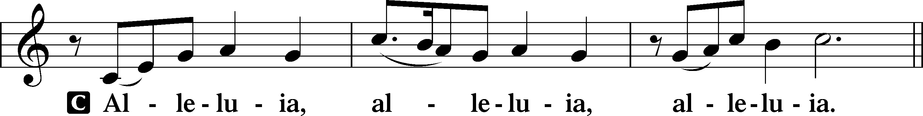
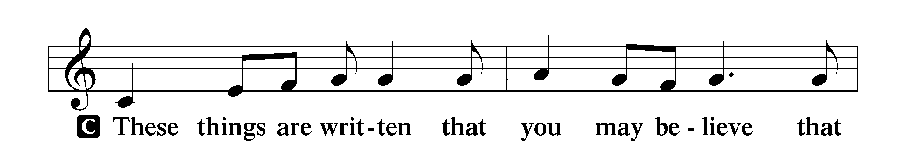
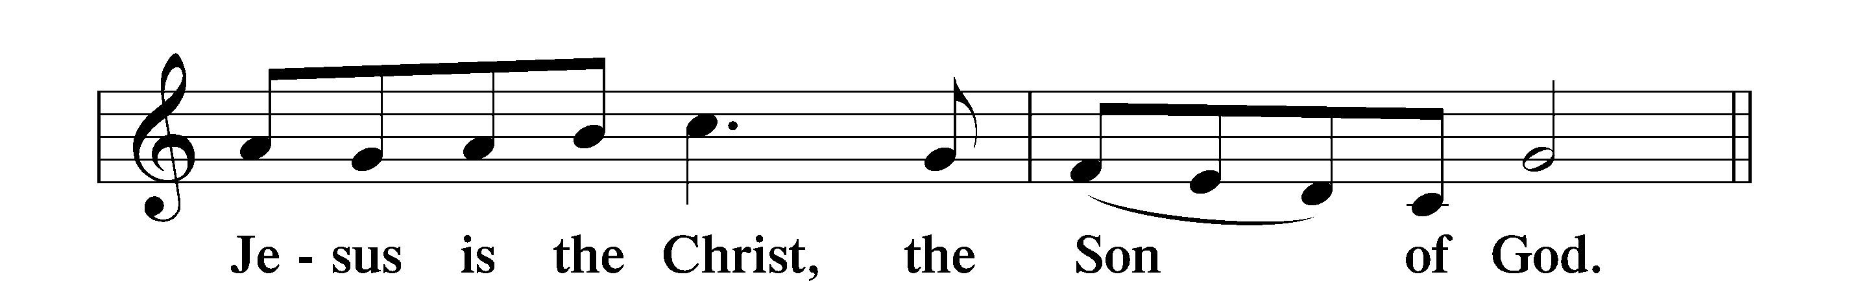
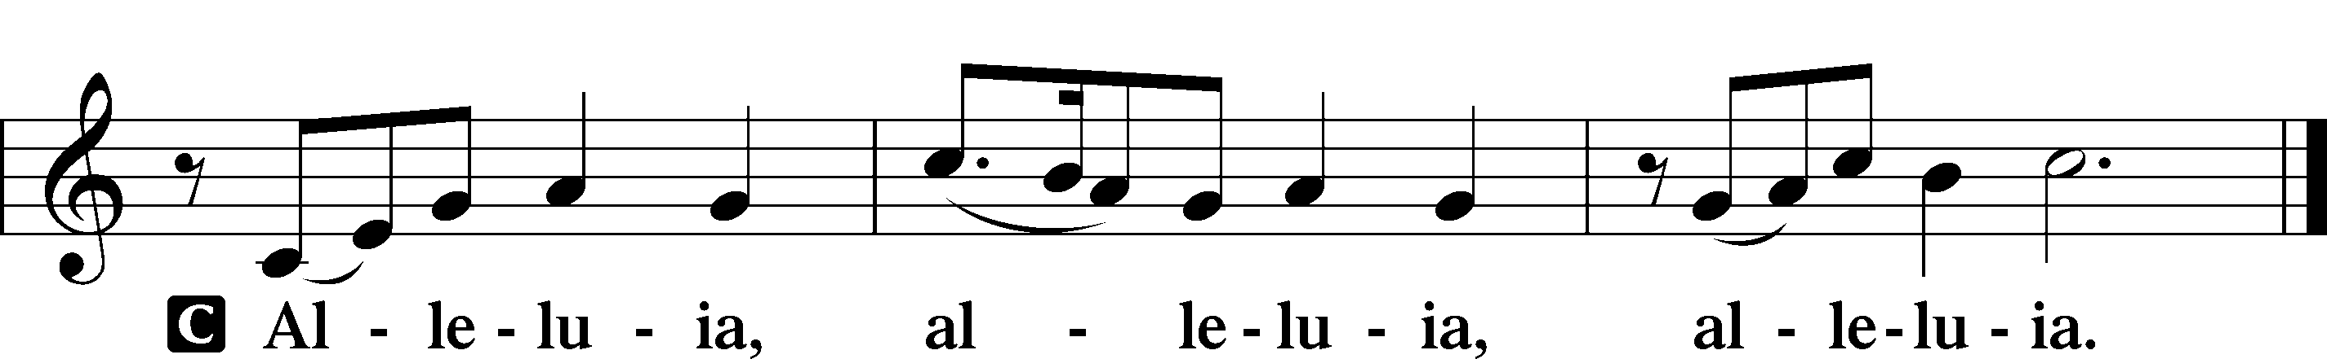

HOLY GOSPEL Luke 12:49–56
P The Holy Gospel according to St. Luke, the twelfth chapter.
C Glory to You, O Lord.
⁴⁹[Jesus said:] “I came to cast fire on the earth, and would that it were already kindled! ⁵⁰I have a baptism to be baptized with, and how great is my distress until it is accomplished! ⁵¹Do you think that I have come to give peace on earth? No, I tell you, but rather division. ⁵²For from now on in one house there will be five divided, three against two and two against three. ⁵³They will be divided, father against son and son against father, mother against daughter and daughter against mother, mother-in-law against her daughter-in-law and daughter-in-law against mother-in-law.”
⁵⁴He also said to the crowds, “When you see a cloud rising in the west, you say at once, ‘A shower is coming.’ And so it happens. ⁵⁵And when you see the south wind blowing, you say, ‘There will be scorching heat,’ and it happens. ⁵⁶You hypocrites! You know how to interpret the appearance of earth and sky, but why do you not know how to interpret the present time?”

P This is the Gospel of the Lord.
C Praise to You, O Christ.
NICENE CREED
C I believe in one God,
the Father Almighty,
maker of heaven and earth
and of all things visible and invisible.
And in one Lord Jesus Christ,
the only-begotten Son of God,
begotten of His Father before all worlds,
God of God, Light of Light,
very God of very God,
begotten, not made,
being of one substance with the Father,
by whom all things were made;
who for us men and for our salvation came down from heaven
and was incarnate by the Holy Spirit of the virgin Mary
and was made man;
and was crucified also for us under Pontius Pilate.
He suffered and was buried.
And the third day He rose again according to the Scriptures
and ascended into heaven
and sits at the right hand of the Father.
And He will come again with glory to judge both the living and the dead,
whose kingdom will have no end.
And I believe in the Holy Spirit,
the Lord and giver of life,
who proceeds from the Father and the Son,
who with the Father and the Son together is worshiped and glorified,
who spoke by the prophets.
And I believe in one holy Christian and apostolic Church,
I acknowledge one Baptism for the remission of sins,
and I look for the resurrection of the dead
and the life T of the world to come. Amen.

Please be seated

ALL GOD’S CHILDREN – TALK

SERMON HYMN
Stand Up, Stand Up for Jesus LSB 660
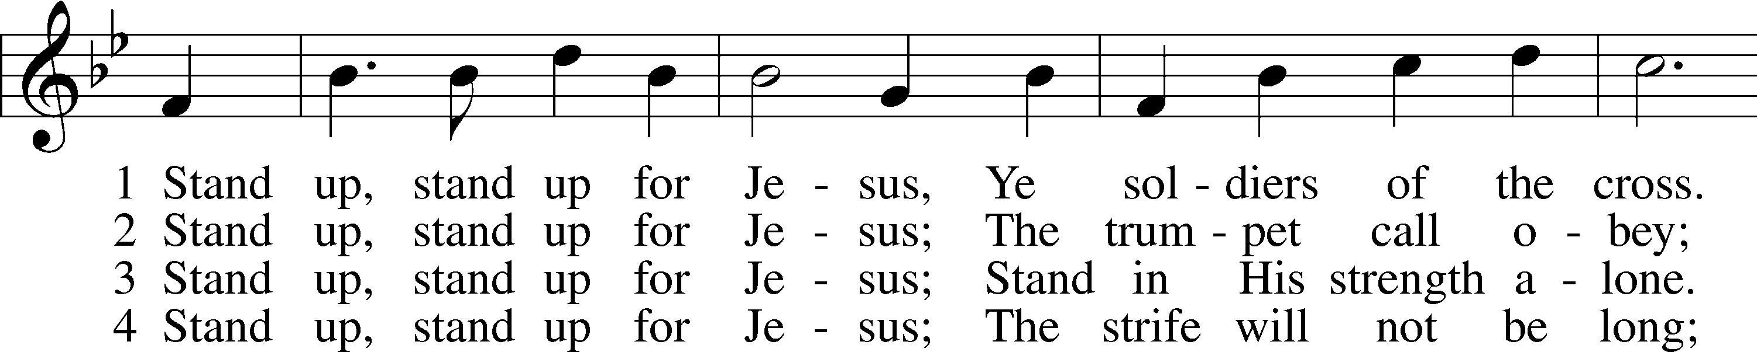
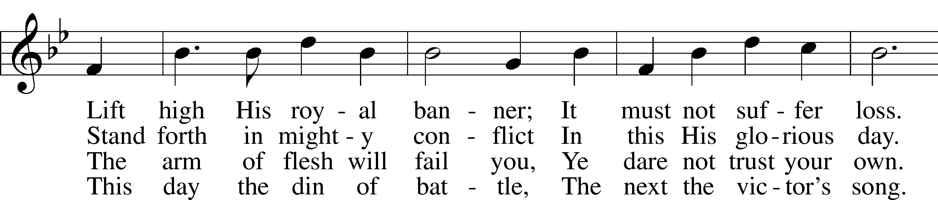
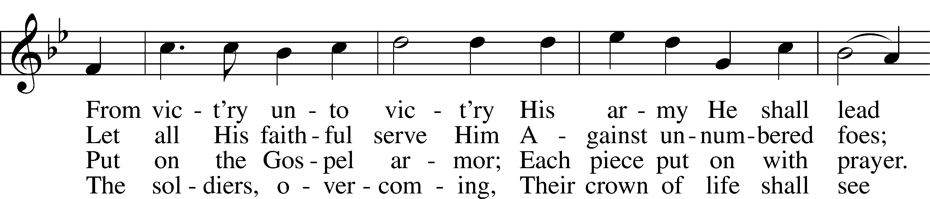
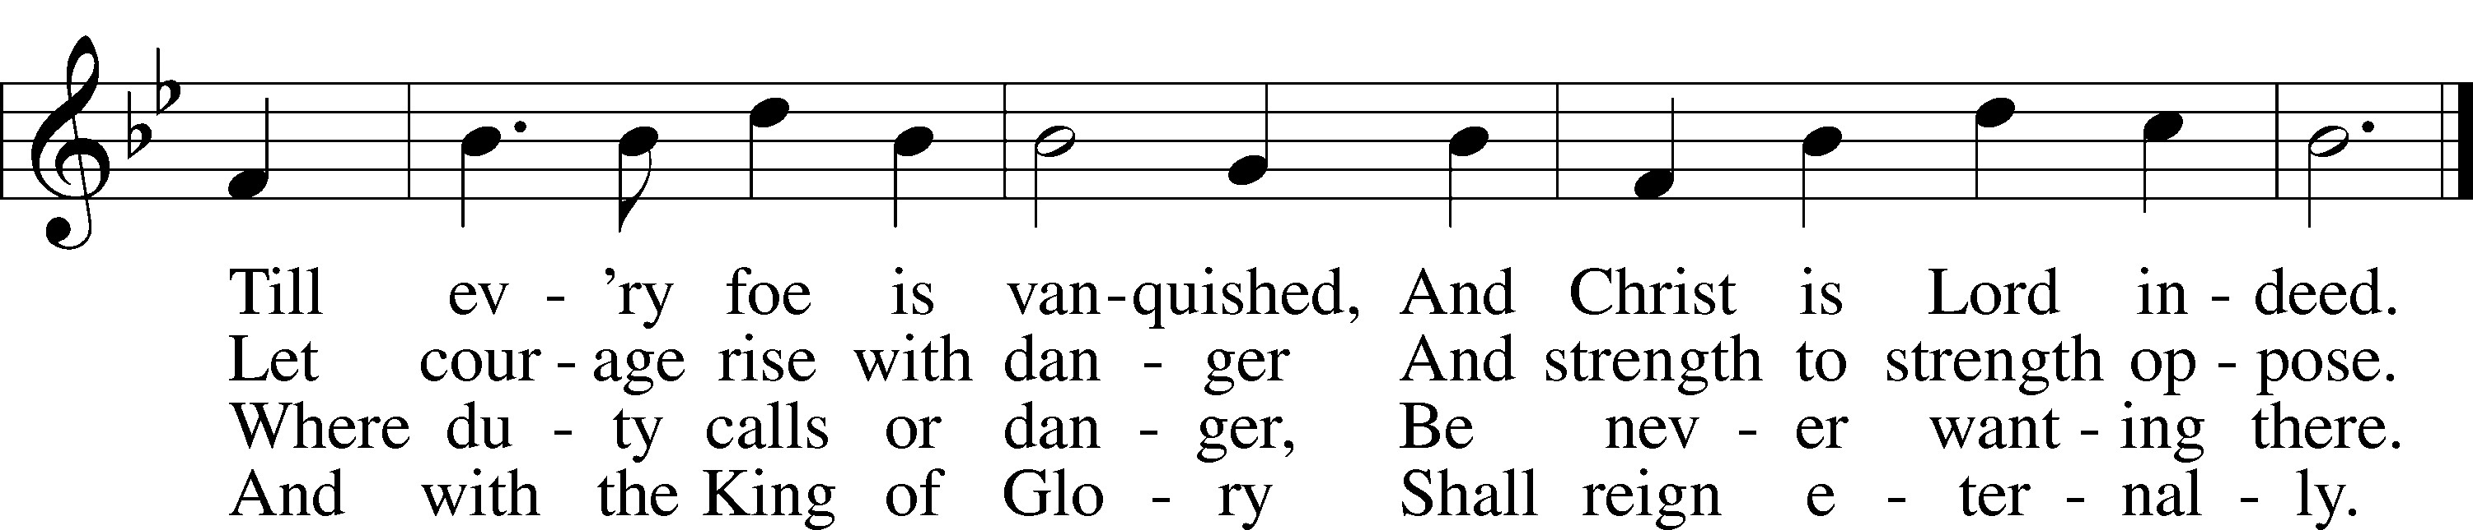
Text: George Duffield, Jr., 1818–88, alt.
Tune: George J. Webb, 1803–87
Text and tune: Public domain

SERMON

Please stand as able

PRAYER of the CHURCH
After each Segment:
P Lord, in Your Mercy,
C Hear our Prayer.
After Final Segment:
P Hear us as we pray in His name and as He has taught us:
LORD’S PRAYER
C Our Father who art in heaven,
hallowed be Thy name,
Thy kingdom come,
Thy will be done on earth
as it is in heaven;
give us this day our daily bread;
and forgive us our trespasses
as we forgive those
who trespass against us;
and lead us not into temptation,
but deliver us from evil.
For Thine is the kingdom
and the power and the glory
forever and ever. Amen.

SERVICE of the SACRAMENT

PREFACE LSB 208
P The Lord be with you.
C And also with you.
P Lift up your hearts.
C We lift them to the Lord.
P Let us give thanks to the Lord our God.
C It is right to give Him thanks and praise.
P It is truly good, right, and salutary that we should at all times and in all places give thanks to You, O Lord, holy Father, almighty and everlasting God, for the countless blessings You so freely bestow on us and all creation. Above all, we give thanks for Your boundless love shown to us when You sent Your only-begotten Son, Jesus Christ, into our flesh and laid on Him our sin, giving Him into death that we might not die eternally. Because He is now risen from the dead and lives and reigns to all eternity, all who believe in Him will overcome sin and death and will rise again to new life. Therefore with angels and archangels and with all the company of heaven we laud and magnify Your glorious name, evermore praising You and singing:

SANCTUS LSB 208
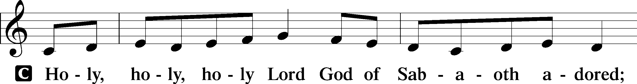
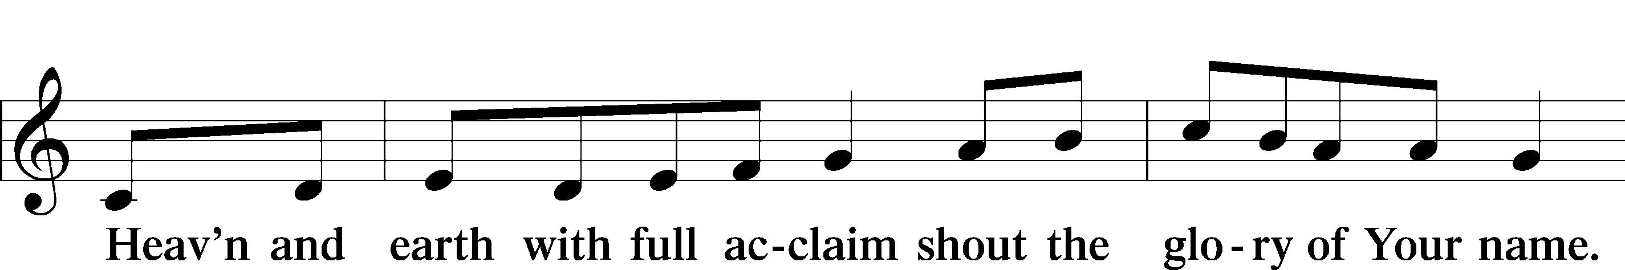
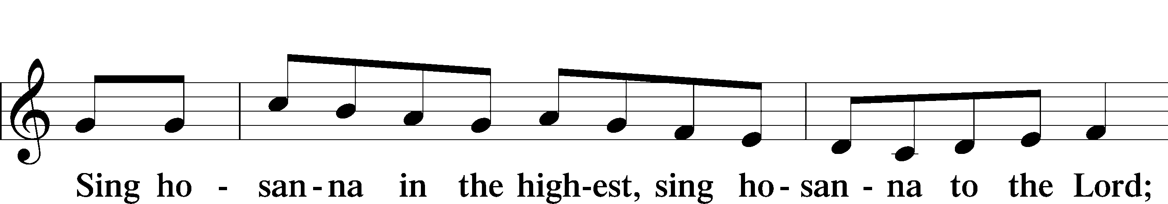
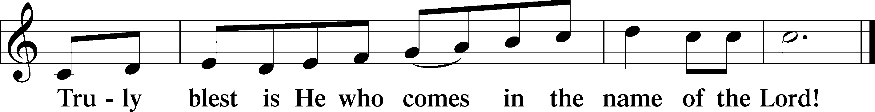

PRAYER OF THANKSGIVING
P Blessed are You, O Lord our God, king of all creation, for You have had mercy on us and given Your only-begotten Son that whoever believes in Him should not perish but have eternal life.
In Your righteous judgment You condemned the sin of Adam and Eve, who ate the forbidden fruit, and You justly barred them and all their children from the tree of life. Yet, in Your great mercy, You promised salvation by a second Adam, Your Son, Jesus Christ, our Lord, and made His cross a life-giving tree for all who trust in Him.

We give You thanks for the redemption You have prepared for us through Jesus Christ. Grant us Your Holy Spirit that we may faithfully eat and drink of the fruits of His cross and receive the blessings of forgiveness, life, and salvation that come to us in His body and blood.

THE WORDS OF OUR LORD
P Our Lord Jesus Christ, on the night when He was betrayed, took bread, and when He had given thanks, He broke it and gave it to the disciples and said: “Take, eat; this is My T body, which is given for you. This do in remembrance of Me.”
In the same way also, He took the cup after supper, and when He had given thanks, He gave it to them, saying: “Drink of it, all of you; this cup is the New Testament in My T blood, which is shed for you for the forgiveness of sins. This do, as often as you drink it, in remembrance of Me.”

PAX DOMINI
P The peace of the Lord be with you always.
C Amen.
AGNUS DEI
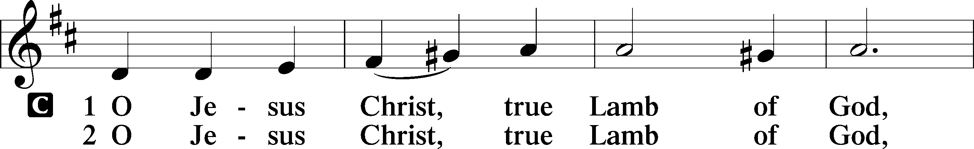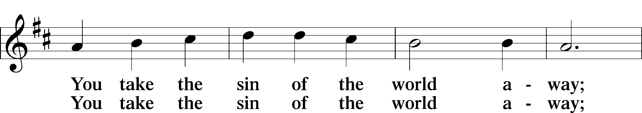
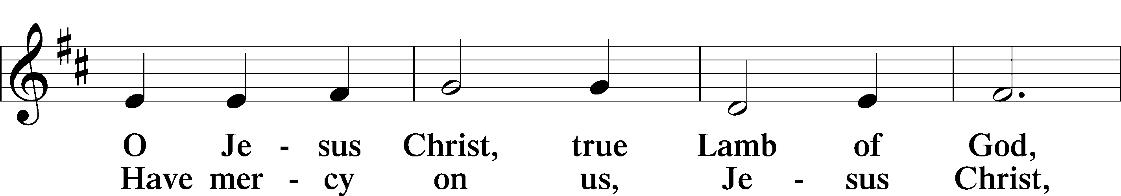
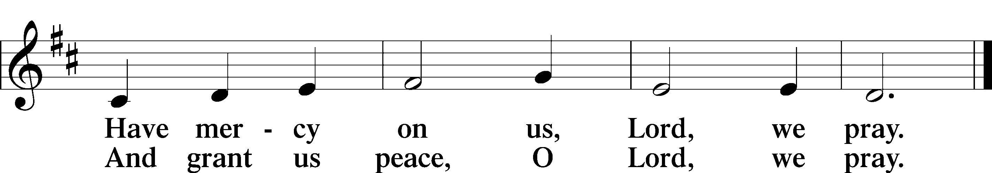

Please be seated
DISTRIBUTION
The pastor and those who assist him receive the body and blood of Christ first, then Communion will be served at the rail. Ushers will help direct you forward via the center aisle; please return to your seats via the side aisles. Gluten-free bread is available for those who need it, as is non-alcoholic grape juice. Simply request either when you come forward to receive Communion.
DISTRIBUTION HYMN
Crown Him with Many Crowns LSB 525
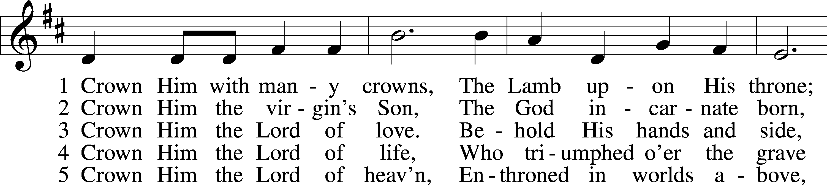
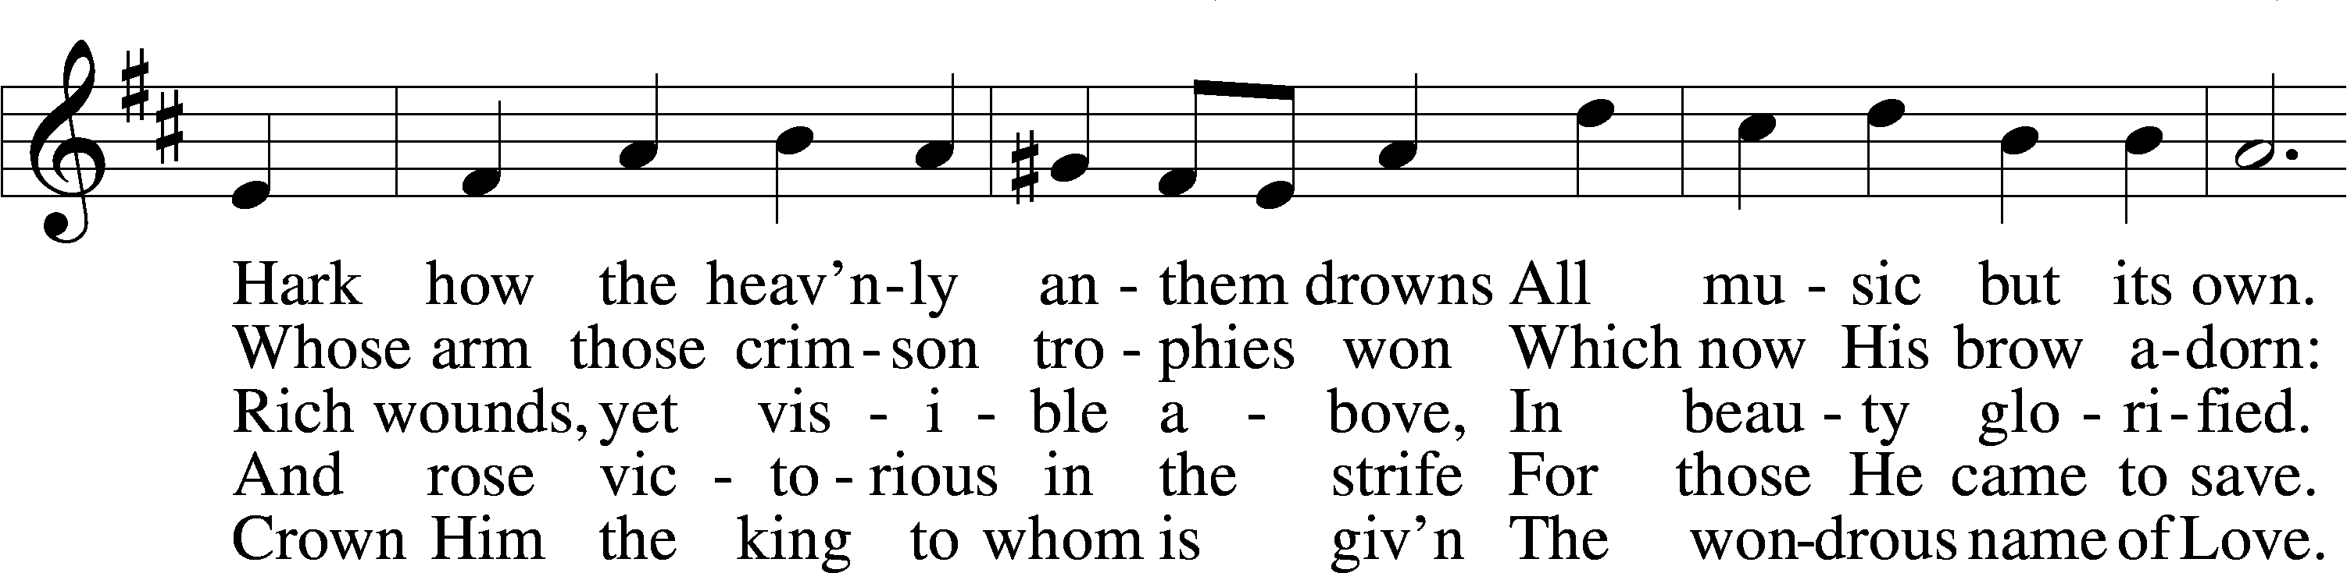
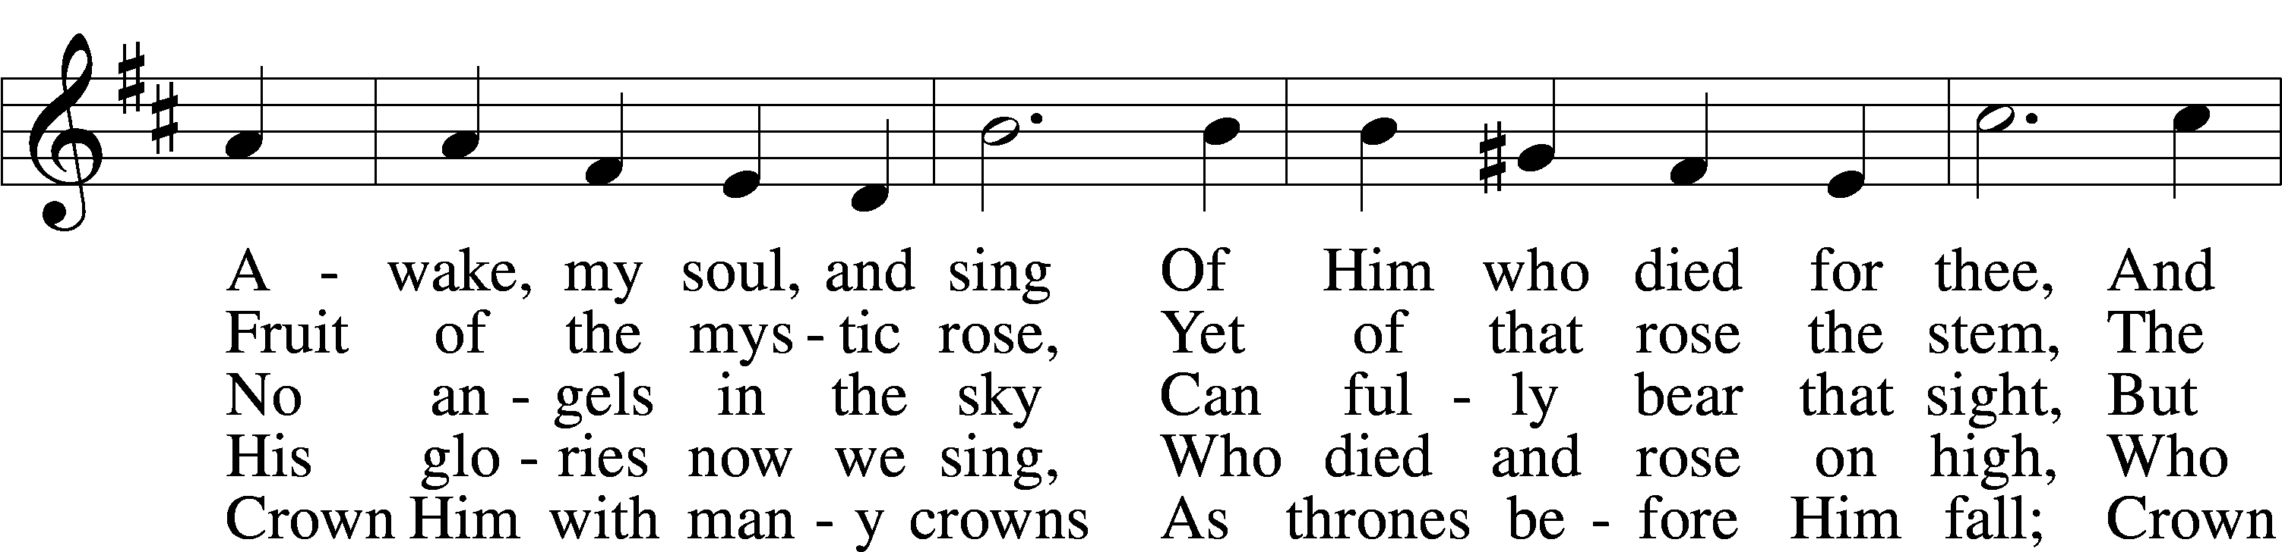
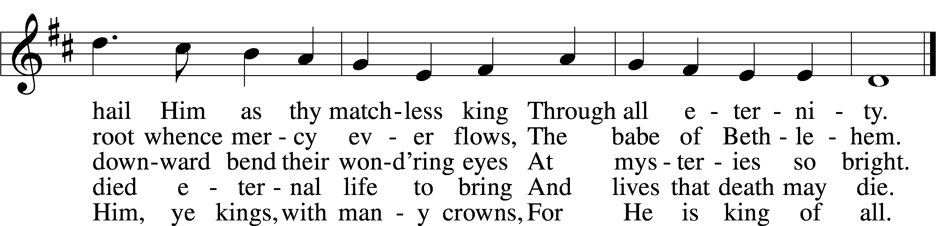
Text (sts. 1–3, 5): Matthew Bridges, 1800–94, alt.; (st. 4): Godfrey Thring, 1823–1903
Tune: George J. Elvey, 1816–93
Text and tune: Public domain
Please stand as able

NUNC DIMITTIS LSB 211
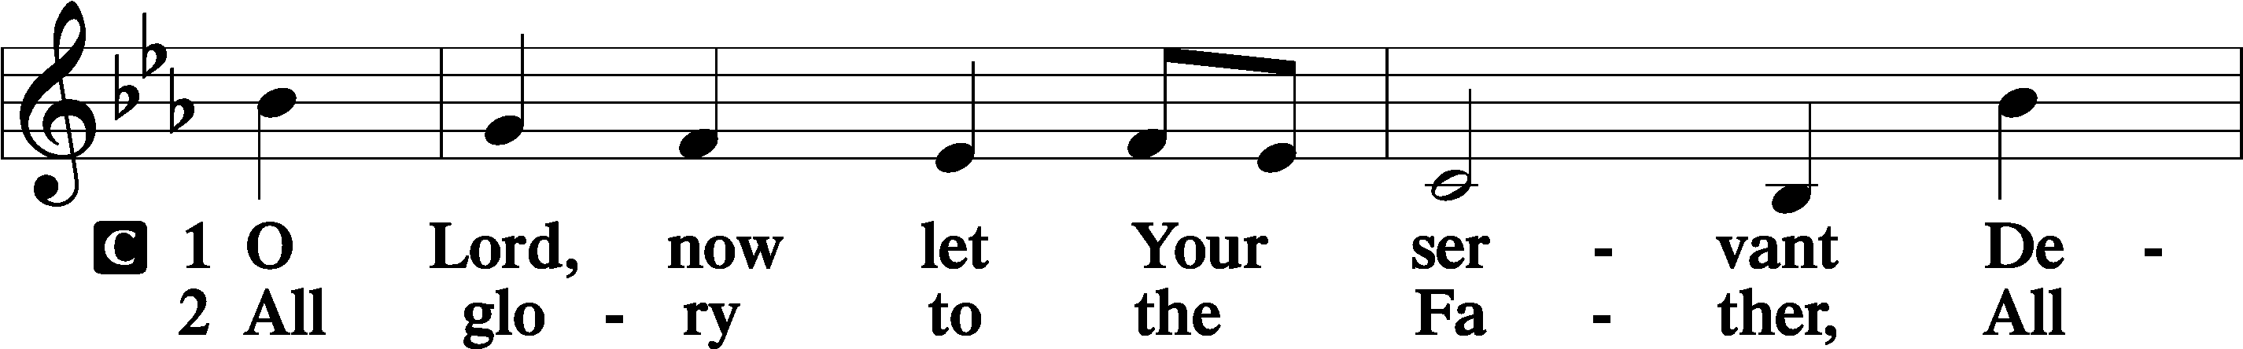
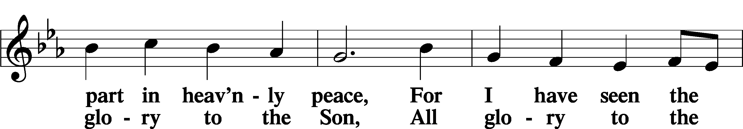
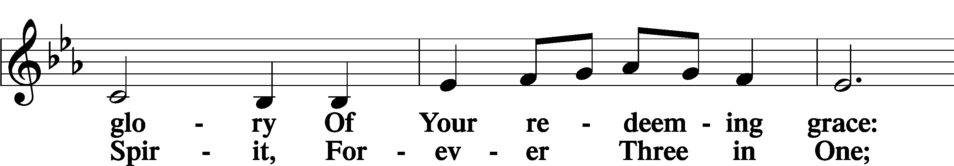
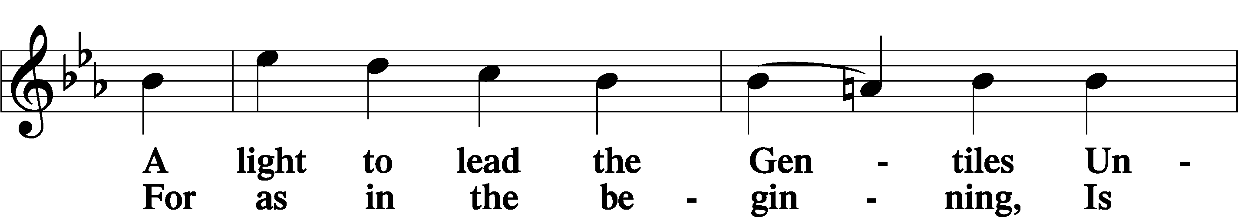
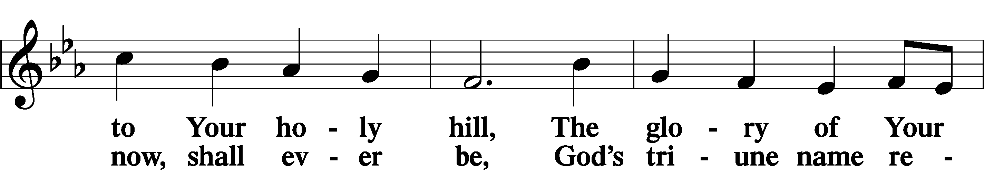
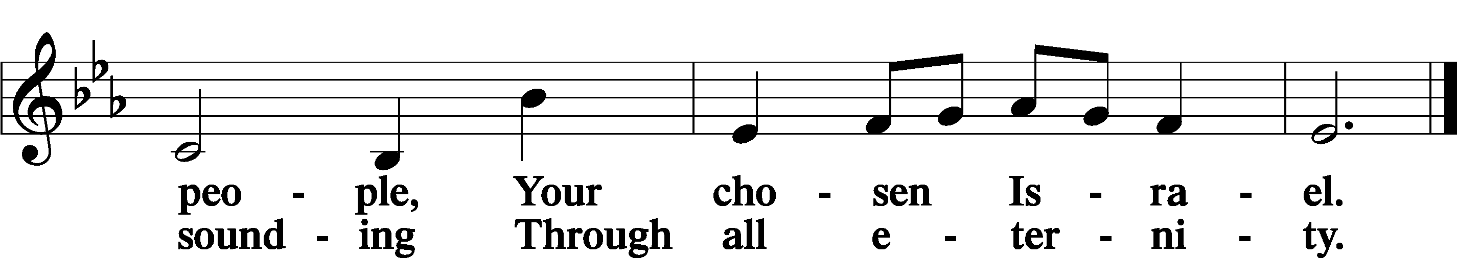

POST COMMUNION COLLECT
P Let us pray.
We give thanks to You, almighty God, that You have refreshed us through this salutary gift, and we implore You that of Your mercy You would strengthen us through the same in faith toward You and in fervent love toward one another; through Jesus Christ, Your Son, our Lord, who lives and reigns with You and the Holy Spirit, one God, now and forever.
C Amen.
BENEDICAMUS LSB 212
P Let us bless the Lord.
C Thanks be to God.
BENEDICTION
P The Lord bless you and keep you.
The Lord make His face shine on you and be gracious to you.
The Lord look upon you with favor and T give you peace.
C Amen.
Please be seated
CLOSING HYMN
Onward, Christian Soldiers LSB 662
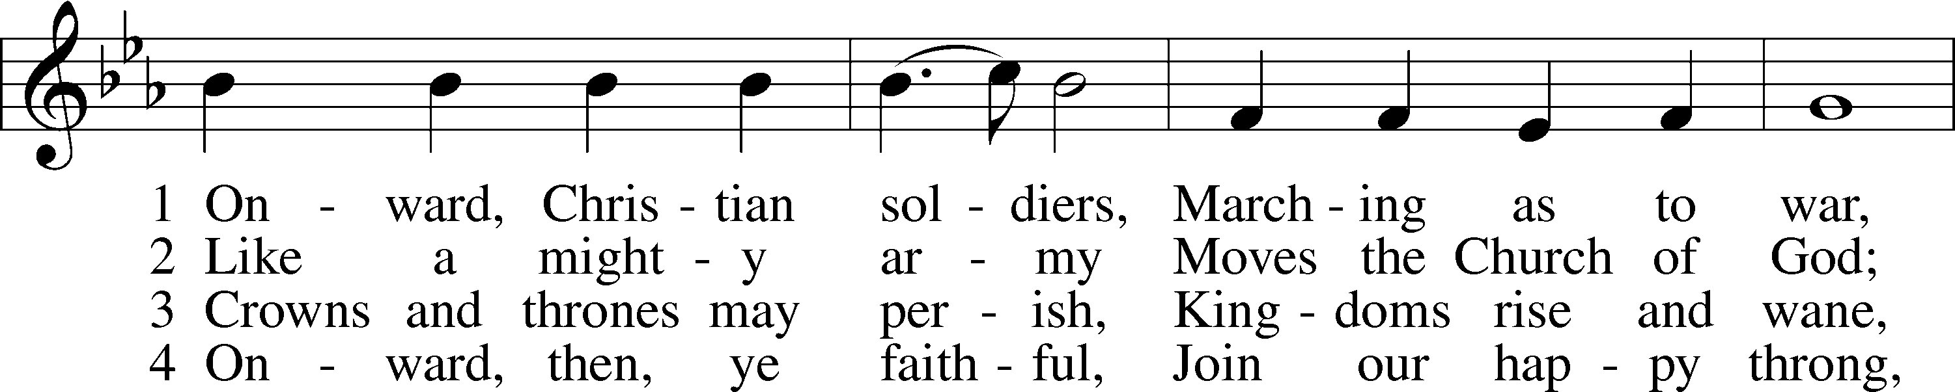
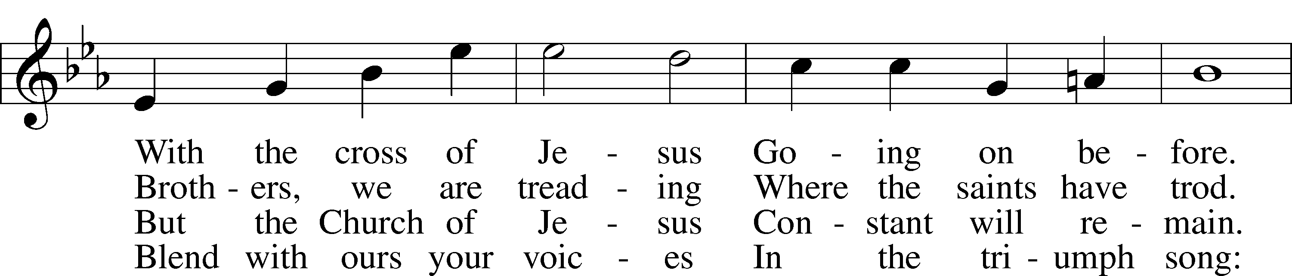
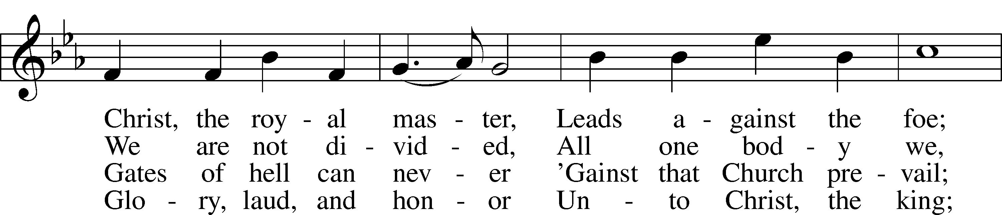
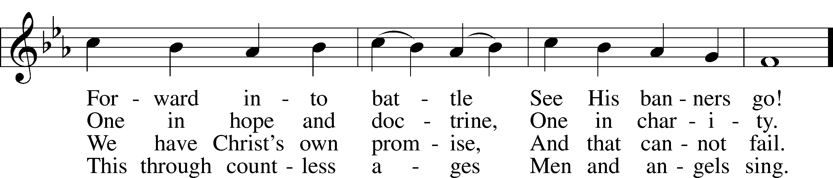
Continued on next page
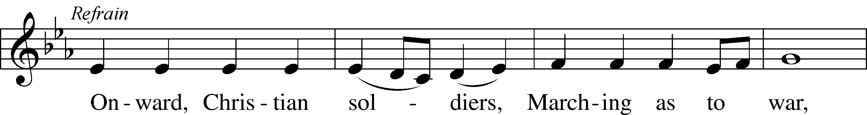
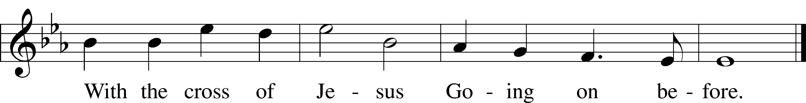
Text: Sabine Baring-Gould, 1834–1924, alt.
Tune: Arthur S. Sullivan, 1842–1900
Text and tune: Public domain

ANNOUNCEMENTS and SENDING WORDS
P We go to live for Jesus!
C We go to share His love!

Acknowledgments
Unless otherwise indicated, Scripture quotations are from the ESV® Bible (The Holy Bible, English Standard Version®), copyright © 2001 by Crossway, a publishing ministry of Good News Publishers. Used by permission. All rights reserved. Created by Lutheran Service Builde

SERVING IN GOD’S HOUSE TODAY
Pastor: Rev. Ken Bernthal
Elder: Glenn Smith
Ushers: Dave Beyers, Roger Raschke
Greeters: Ken & Ann Mertz
Counters: Nancy Ely, Sandy Smith
Coffee Servers: Mertz
Altar Care: Jeanine Boldrey
Piano/Organist: Tom & Jean Beach
Children’s Talk: Nancy Ely
Post-Service Bible Study to resume in September.

PRAYERS
Please contact the office with updates to the prayer list. People will remain on the prayer list for 4 weeks before being removed. If they need to remain on the list, please keep Elaine informed and of any updates. This will help us to have a more accurate list. Thanks for your cooperation.
Those who continue to grieve the passing of loved ones, The Family of Vickie Gami (LWML Servant)
Those with upcoming surgery: Joann Whitney (August 23rd)
Those recovering from surgery: Tom Beach
Those with health concerns: Tiffany Amsdill, Laurie Breen, Hope Buchinger,
Betsy Cook, Kay Gregg, Paul Kietzman, Hilda Koch, Jennifer Martin, Ron Kwapis, Eleanor Raether, Beth Smith, Judi Stutzman, and Joann Whitney.
Those diagnosed with cancer: Leah Eicher, Rachel Frisch, Janice Knoellinger, Leslie Martin, Brian Morgan, Hope Osantowski, and John Stutzman.
Those under Hospice Home Care: Ken Williamson, Jim (Joann Whitney’s brother-in law).

BIRTHDAYS: ANNIVERSARIES;
8/14 Jean Seibel 8/13 Roger & Elaine Raschke
8/15 Ken Williamson
8/17 Richard Kowalsky
MESSAGES

ALTAR FLOWERS today are given to the glory of God by Roger & Elaine in celebration of their 56th Anniversary.
MEMBER & GUEST CARDS: If you have not filled out a member/guest card, please take the time to fill one out and place it in the plate behind the back pews in our sanctuary.
GREETING CARDS If you are in need of some greeting cards, we carry an array of them. The card cabinet is in the hallway across from the library. The cost of the cards is posted on the cabinet. The money collected from the cards goes to LWML to help support Missions.
CANCER and FRIENDS SUPPORT GROUP: Will be meeting in August 23rd. Our guest speaker will be Shannon Smith from Yoga 45. Please remember Cancer & Friends Support Group is not just for people going through treatment, or survivors, we are also here for caregiver, spouse, children, and friends. There are times when we can all use someone to talk to during those difficult times. If there is any subject you would like to discuss with me you call or text or at 989-350-4391. Hope you will join us.
CHURCH EXTENSION FUND has proven investment products with measurable results. Since 1901, through dedicated Christian financial management, CEF is focused on funding the needs of Michigan District congregations. (Proven, Dedicated, Focused)
For more information, contact (Congregation Representative and telephone number) or call 800-242-3944.
WEDNESDAY MORNING BIBLE STUDY will resume in September
PLANNING MEETING FOR LWML meetings activities and projects will be held Tuesday, August 16 at 10 AM at church. Everyone is welcome. We would love to plan some things that everyone would like. We hope you join us.

THIS WEEK AT TRINITY

August 14 Sunday
9:00 am Worship Service
10:00 am Fellowship & Coffee Hour
August 15 Monday
August 16 Tuesday
10:00 am LWML Planning Meeting (Fellowship Hall)
August 17 Wednesday
August 18 Thursday
August 19 Friday
August 20 Saturday
August 21 Sunday
9:00 am Worship Service
10:00 am Fellowship & Coffee Hour

SERVING IN GOD’S HOUSE NEXT SUNDAY 8/21/2022
Pastor: Rev. Paul Schneider
Elder: Tom Raithel
Ushers: Mike Goodrich, Risa Sherman
Greeters: Bob & Kathy Erat
Counters: Ric Francis, Kathy Erat
Coffee Servers: Kunisch
Altar Care: Ann Mertz
Virtual Organist: Bob Erat
Children’s Talk: Nancy Ely
Post-Service Bible Study to resume in September.

